**Ghost OG**

This indica-dominant strain is a potent relaxant that inherited the characteristics that Kush strains are loved for. Ghost OG is a [high-THC](http://www.ilovegrowingmarijuana.com/highest-thc-strains/)type of strain that promises a full cerebral experience that is marked with a sweet and citrus tasting yet creamy smoke.

Ghost OG is a phenotype of legendary hybrid [OG Kush](http://www.ilovegrowingmarijuana.com/og-kush/), a strain that is known for its supreme cerebral high and soothing body effects. This hybrid is potent without being overwhelming, allowing you to stay in control of your high while fully succumbing to its effects.

This strain is a powerful medical variant, with a long list of healing abilities. Ghost OG has won some Cannabis Cup awards, and rightfully so. This strong indica-dominant strain that is an ideal choice when on the search for a way to feel relaxed, especially with a little experience under your belt.

**Information about Ghost OG:**

|  |  |
| --- | --- |
| ORIGIN | OG Kush mixed with Afghani |
| EFFECTS | relaxed – 10 happy – 8 uplifted – 6 euphoric – 5 creative – 5 |
| ADVERSE REACTIONS (NEGATIVE) | dry mouth – 10 dry eyes – 2 paranoid – 1 dizzy – 1 headache – 1 |
| FRAGRANCE | citrus, orange, pine, sweet |
| FLAVORS | citrus, earthy, sweet, pungent, orange |
| MEDICAL | stress – 10 pain – 8 insomnia – 7 depression – 7 lack of appetite – 5 |
| FLOWERING TIME INDOORS | 8-9 weeks |
| FLOWERING TIME OUTDOORS | early October |
| PLANT HEIGHT | Medium |
| THC CONTENT % | 18%-24% |
| CBD % | 0.30% |
| INDICA / SATIVA % | 70% / 30% |
| INDOOR YIELD | 11oz/ m2 |
| OUTDOOR YIELD | 9oz/ plant |
| CLIMATE | sunny and warm Mediterranean climate |
| GROWTH LEVEL | easy |
| RESISTANCE TO DISEASE | resistant to common molds and mildew |

*\* 10 is the highest  
* 1 is the lowest*

**Effects**

Ghost OG induces a strong physical and mental sedation, that can be traced back to its roots. This strain creates a potent feeling of being relaxed, slowly unraveling your thoughts and allowing any heaviness to dissipate. It is perfect as an end of the day toke, in order to calm any strained nerves.

*TIP: Looking to*[*buy Ghost OG seeds*](https://shop.ilovegrowingmarijuana.com)*? Check out this*[*marijuana seed shop*](https://shop.ilovegrowingmarijuana.com/)

This indica-dominant strain is easily one of the best good-mood inducer out there too. Ghost OG can infuse you with feelings of positivity and make you feel lifted and relieved of your worries. This strain can unwind you without making you feel heavy, but may cause you to feel sleepy when you smoke much of it.

[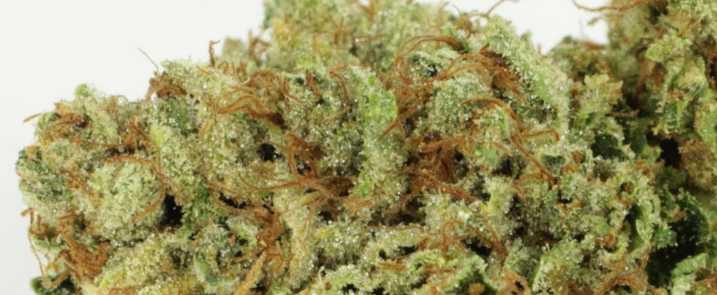](http://www.ilovegrowingmarijuana.com/wp-content/upload_folders/ilovegrowingmarijuana.com/2017/05/Ghost_OG_Effects.png)

*Ghost OG Effects – Image powered by*[*Darkheartnursery.com*](http://darkheartnursery.com)

Ghost OG is also known for making you feel uplifted and elated, adding sudden bursts of euphoria to your already enjoyable high. This variant can also encourage you to be more creative than your usual self, as it is inspiring and will allow you to think outside of the box, especially if you naturally inclined to being artistic.

**Fragrance**

Ghost OG is an especially fragrant variety, filling the room with its energizing aroma. This strain also contains traces of sweetness and fresh pine, adding greatly to the joy of smoking it and easily making your mouth water for more.

**Flavors**

This strain is noteworthy, even in its flavors. Ghost OG has a smoke that tastes earthy on the inhale, with bits of sweetness and orange, too. This strain is very pungent, in its taste too, and is guaranteed to leave a sticky sweet citrus taste on your tongue that will stick around for a while.

**Adverse Reaction**

Ghost OG is a potent strain, yet it displays fairly minimal side effects as opposed to other strong variants. This indica-dominant strain may leave you with the usual dry mouth and dry and itchy eyes, making you feel slightly dehydrated and in need of water.

[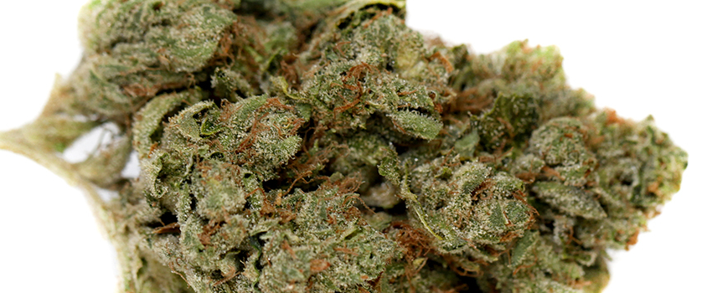](http://www.ilovegrowingmarijuana.com/wp-content/upload_folders/ilovegrowingmarijuana.com/2017/05/Ghost_OG_Adverse_Reaction.png)

*Ghost OG Adverse Reaction – Image powered by*[*Miragemedicinal.com*](http://miragemedicinal.com)

Other adverse effects you may experience from smoking this strain include a mild feeling of paranoia, which may also be accompanied by a slight dizziness. In some cases, smoking Ghost OG may also leave you with a slight headache, often attributed to the feeling of being dehydrated.

**Medical**

Ghost OG is a popular medical strain that is used for an array of mental and physical conditions. This strain is a powerful stress-relieved, allowing even patients with chronic stress issues to find a way to calm their nerves and find themselves in a more relaxing state.

*TIP: Looking to*[*buy Ghost OG seeds*](https://shop.ilovegrowingmarijuana.com)*? Check out this*[*marijuana seed shop*](https://shop.ilovegrowingmarijuana.com/)

This hybrid leans strongly on its indica effects, allowing medical patients who are long-time sufferers of [chronic pain](http://www.ilovegrowingmarijuana.com/chronic-pain/) and muscle spasms to find relief. Ghost OG can alleviate persistent pain such as joint aches and [migraines](http://www.ilovegrowingmarijuana.com/migraine-medical-marijuana/), and allow you to find a consistent state of relaxation.

Ghost OG has also proven itself to be useful in the fight against insomnia, as it can make you feel sleepy, especially in higher doses. This strain may also help [cancer patients](http://www.ilovegrowingmarijuana.com/can-the-use-of-medical-marijuana-be-beneficial-for-cancer-patients/) who are undergoing chemical treatments to soothe any depressive feelings, as well as restore their appetites, but eliminating the usual nausea.

**Growing**

Ghost OG is an easy strain to cultivate, as it is generally fuss-free and adapts well to sunny and warm Mediterranean climates. This strain is an average yielder, but makes up for it by being resistant to many common diseases, and being low-maintenance in nature.

[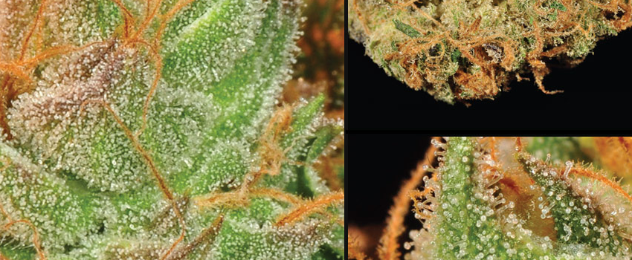](http://www.ilovegrowingmarijuana.com/wp-content/upload_folders/ilovegrowingmarijuana.com/2017/05/Ghost_OG_Growing.png)

*Ghost OG Growing – Image powered by*[*Lightshade.com*](http://lightshade.com)

**Flowering Time**

Indoors  
Ghost OG grown indoors can be expected to take an average of about 8 to 9 weeks to flower and be ready for a [harvest](http://www.ilovegrowingmarijuana.com/harvesting/). This strain can [yield](http://www.ilovegrowingmarijuana.com/marijuana-cannabis-yield-how-much/) around 11 ounces of fresh bud during harvest.

Outdoors  
This flower is usually available for an outdoor harvest around early October, as it flowers throughout the late summer. Ghost OG can yield around 9 ounces of bud per plant cultivated.

Have you ever smoked or grown your own Ghost OG? Please let me know what you think about this marijuana strain in the comments below.

Robert